Name:

Examine the following code, what test cases do you recommend:

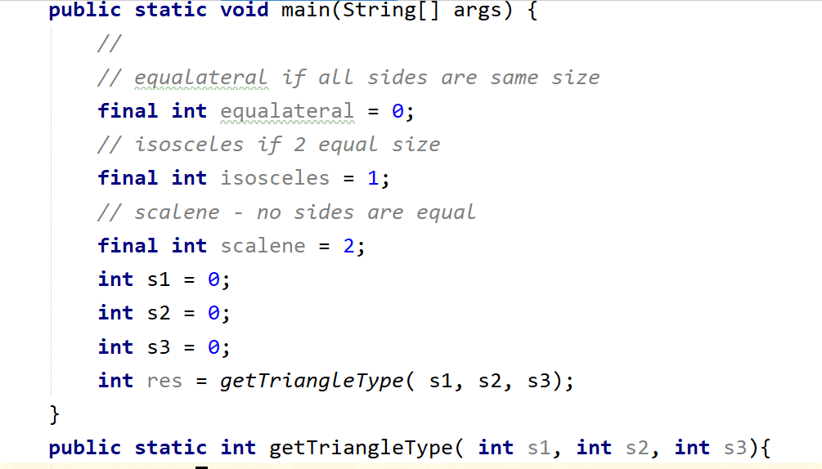

What test cases you would recommend to consider the getTriableType() method well tested?